**Money Management App**

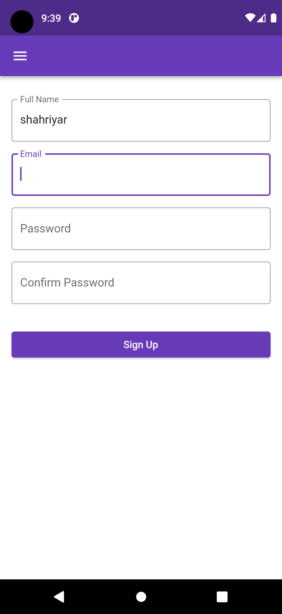

**Sign Up Screen:** After opening the application, First user must Sign up with their details to use this application. After successful Sign up, user automatically redirect to the application homepage.

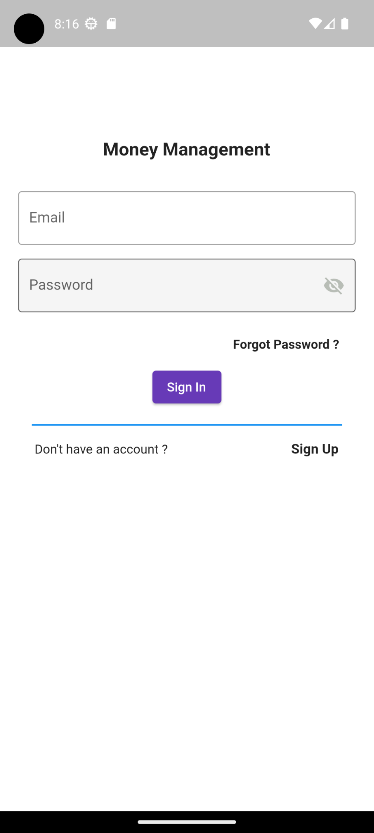

**Sign In Screen:** Also which user already have account, they can directly use the application by Logging in. To Log In user must input a valid email and password.

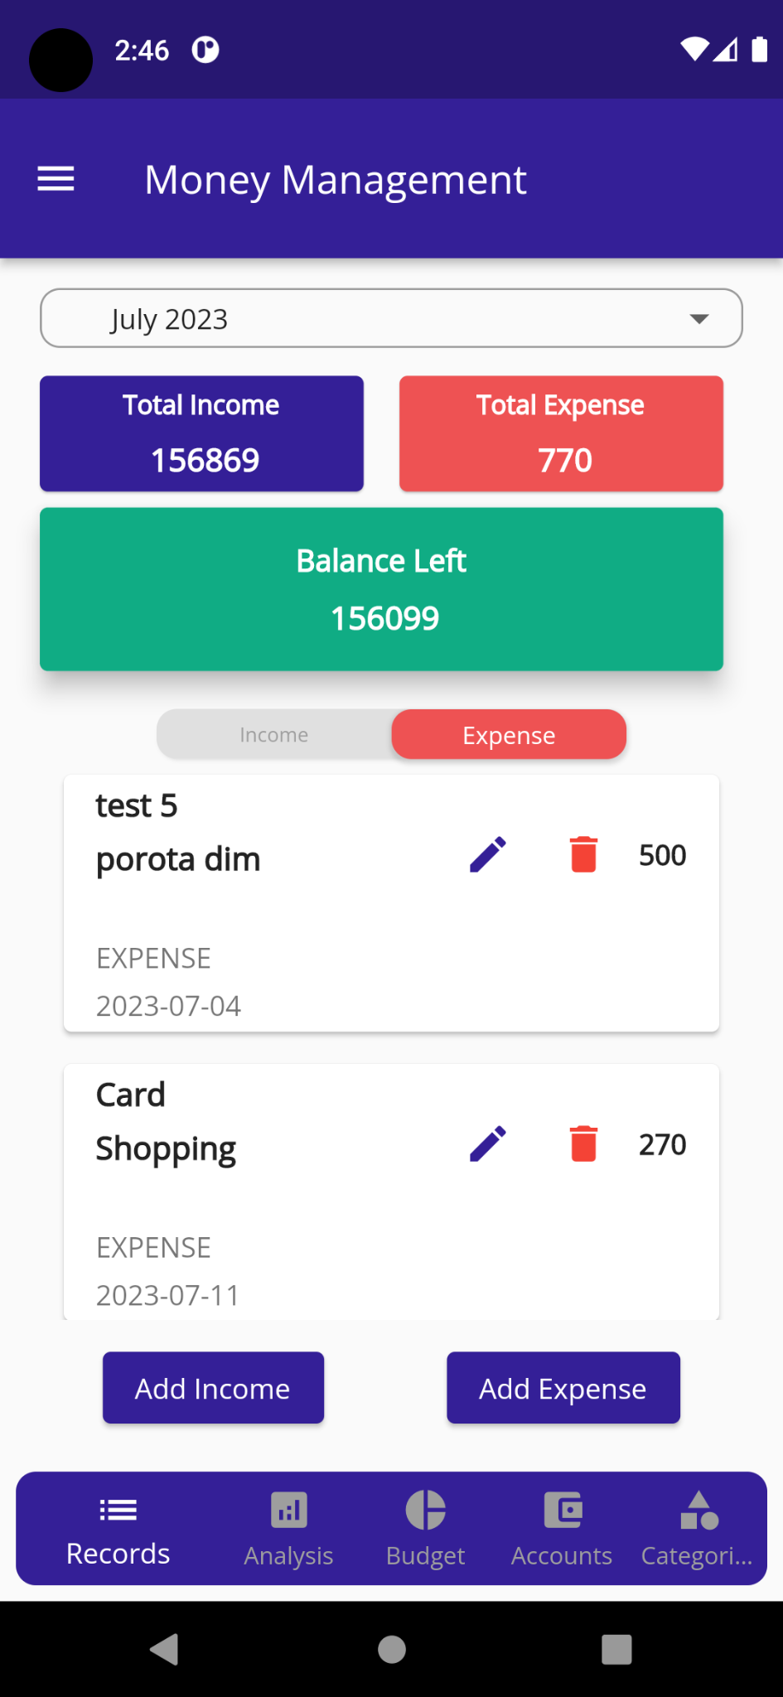**HomePage Screen:** After successful authentication, the user can see the app homepage screen. In this screen, user can see the total expense, income and the rest of the savings. User can also see the monthly income and expense list (by switching the tab) by default. But if user want to see a specific time period list then user must select or set the starting and ending date.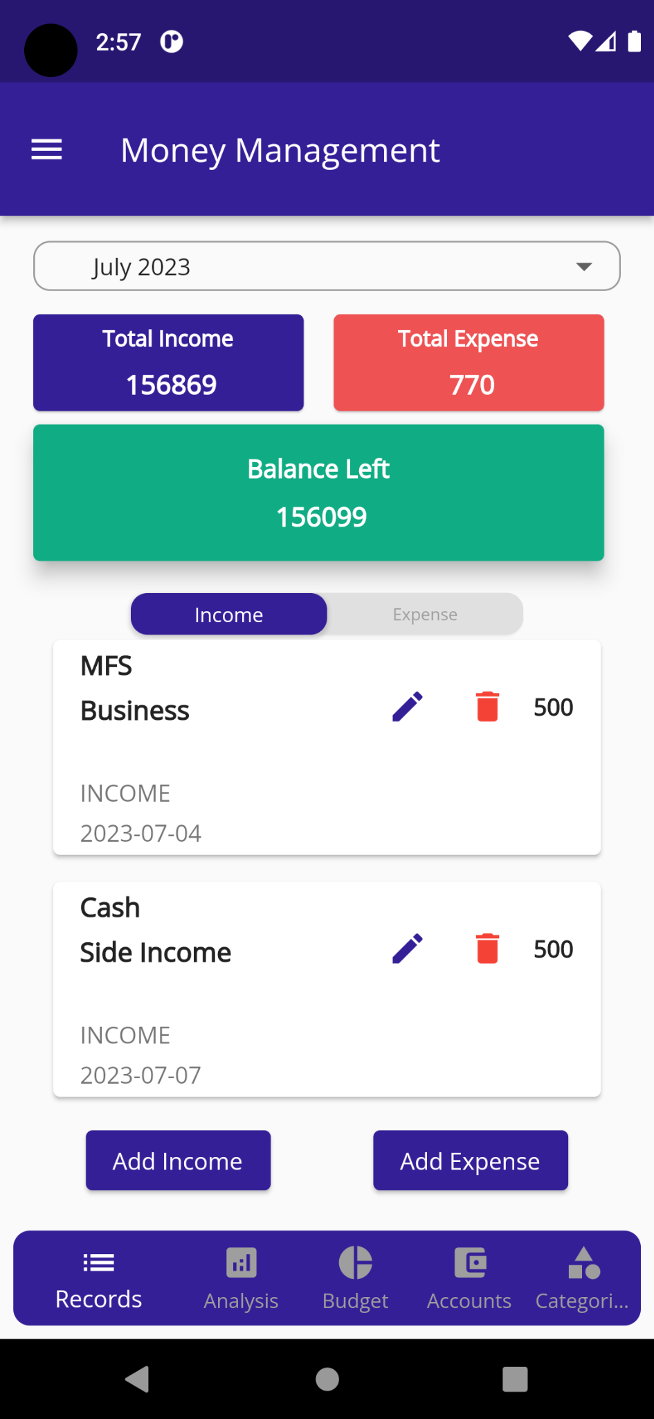

User will go to the add Income or Expense Screen after clicking the **Add Income** and **Add Expense** button. Also user can open the side navigation panel by clicking the **drawer** button.

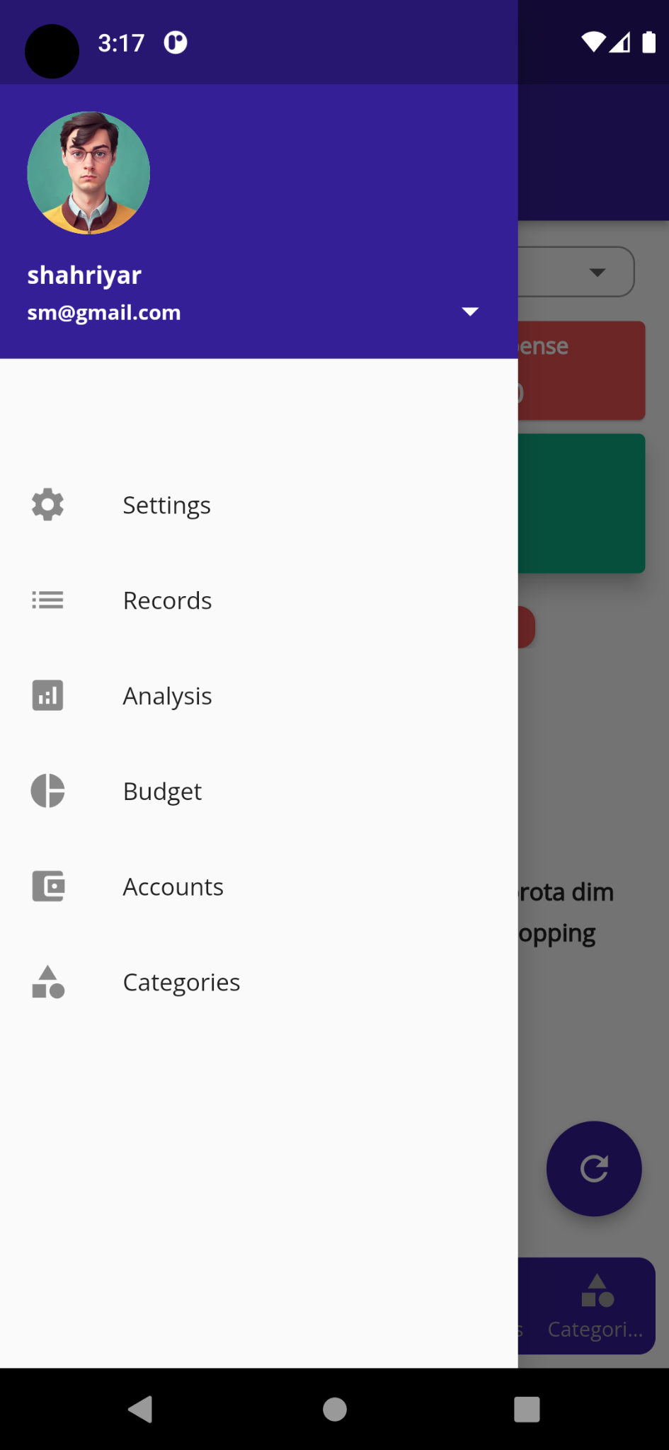

**Side Navigation Panel:** In this screen, user will see the menu options like, settings, records, Analysis, Budget, Accounts, Categories. User can navigate those page by clicking the options. User also see his/her email, name and photo from the side panel window.

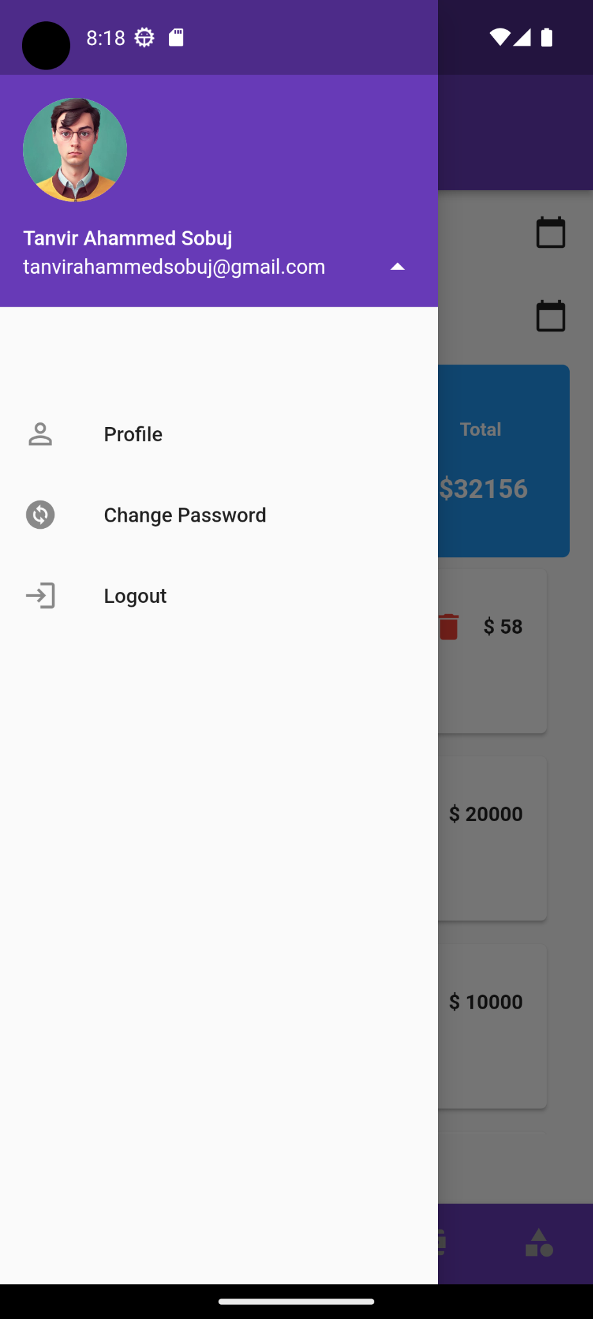

**Email Dropdown:** After clicking the email dropdown menu, user will see a dropdown list screen with **profile**, **change password** and **logout** button. User can navigate those pages by clicking the button options.

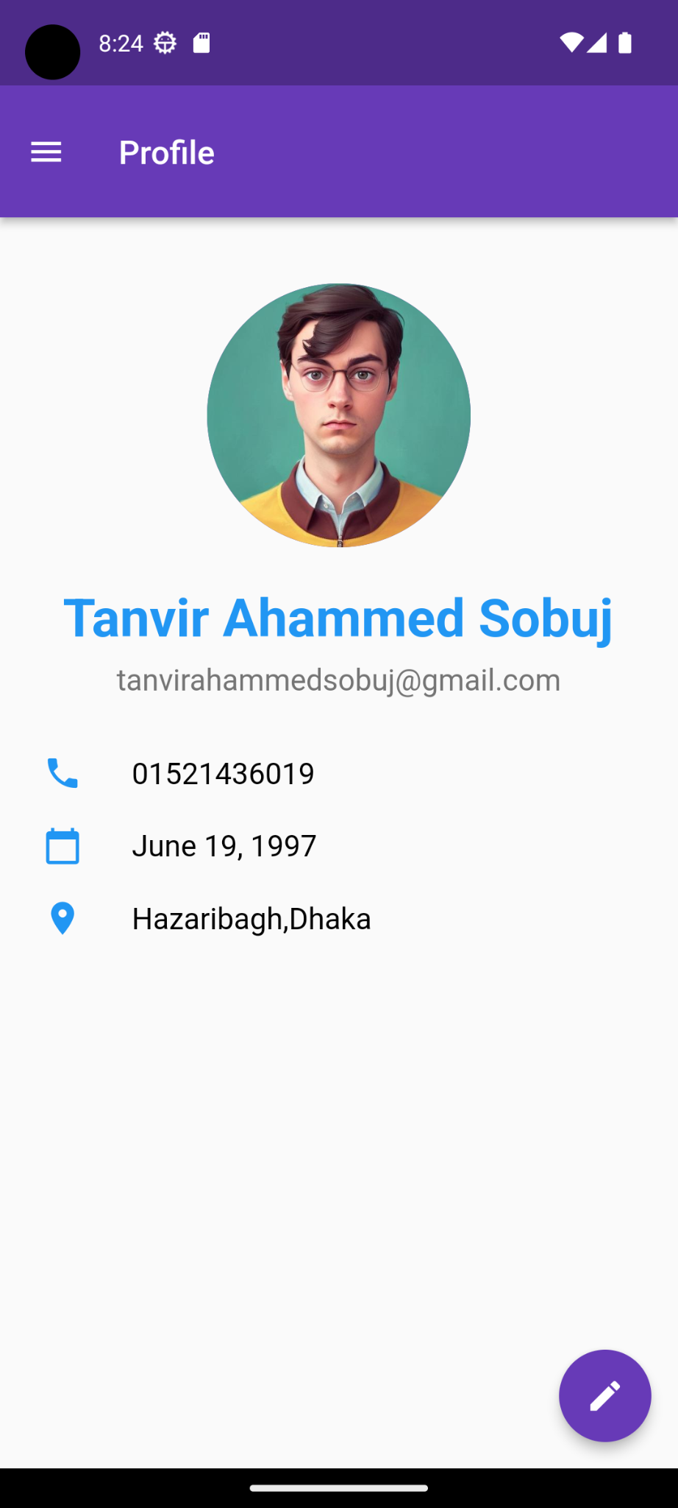

**Profile Screen:** After Clicking the profile button, user will see this profile page. Here, user can see his/her name, email, phone number, address and birth date. User will see a **profile edit button** in the right bottom corner to edit the profile details.

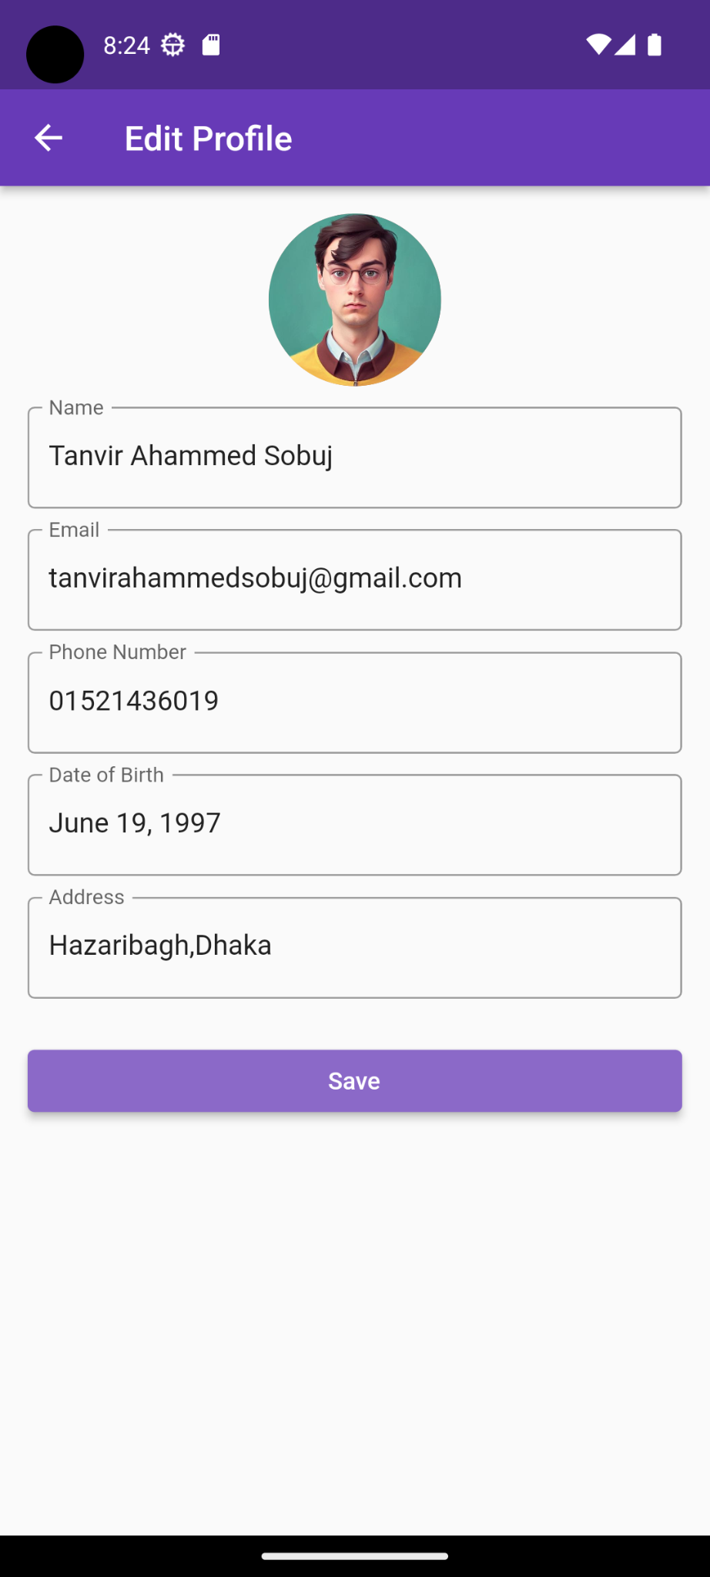

**Profile edit Screen:** after clicking the profile edit button, user will see the profile edit screen. Here user user will change the details of his/her own.

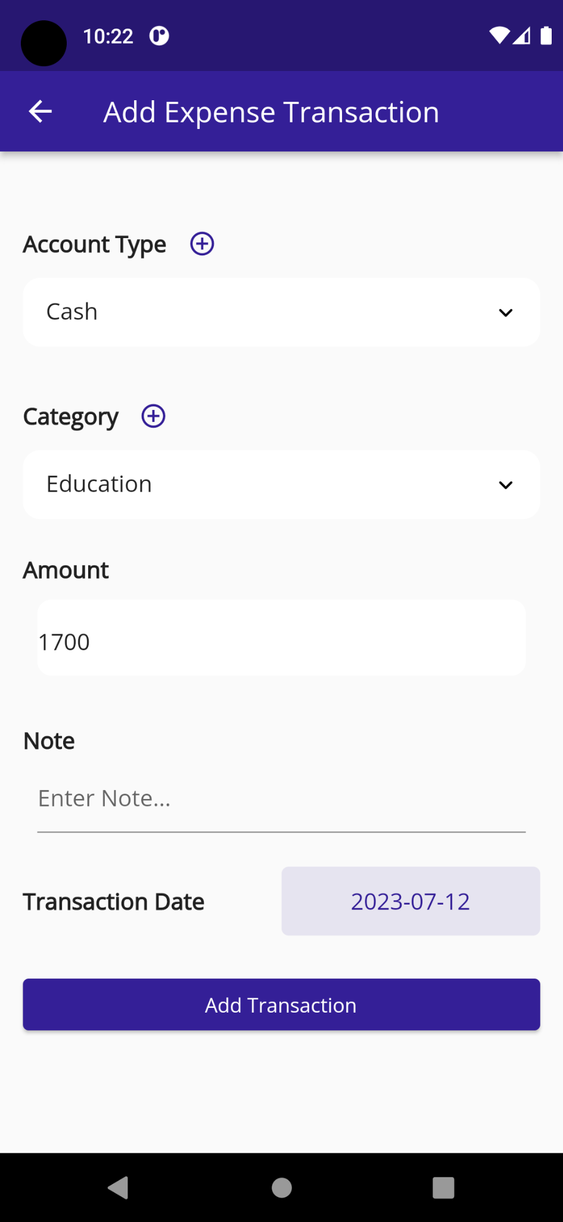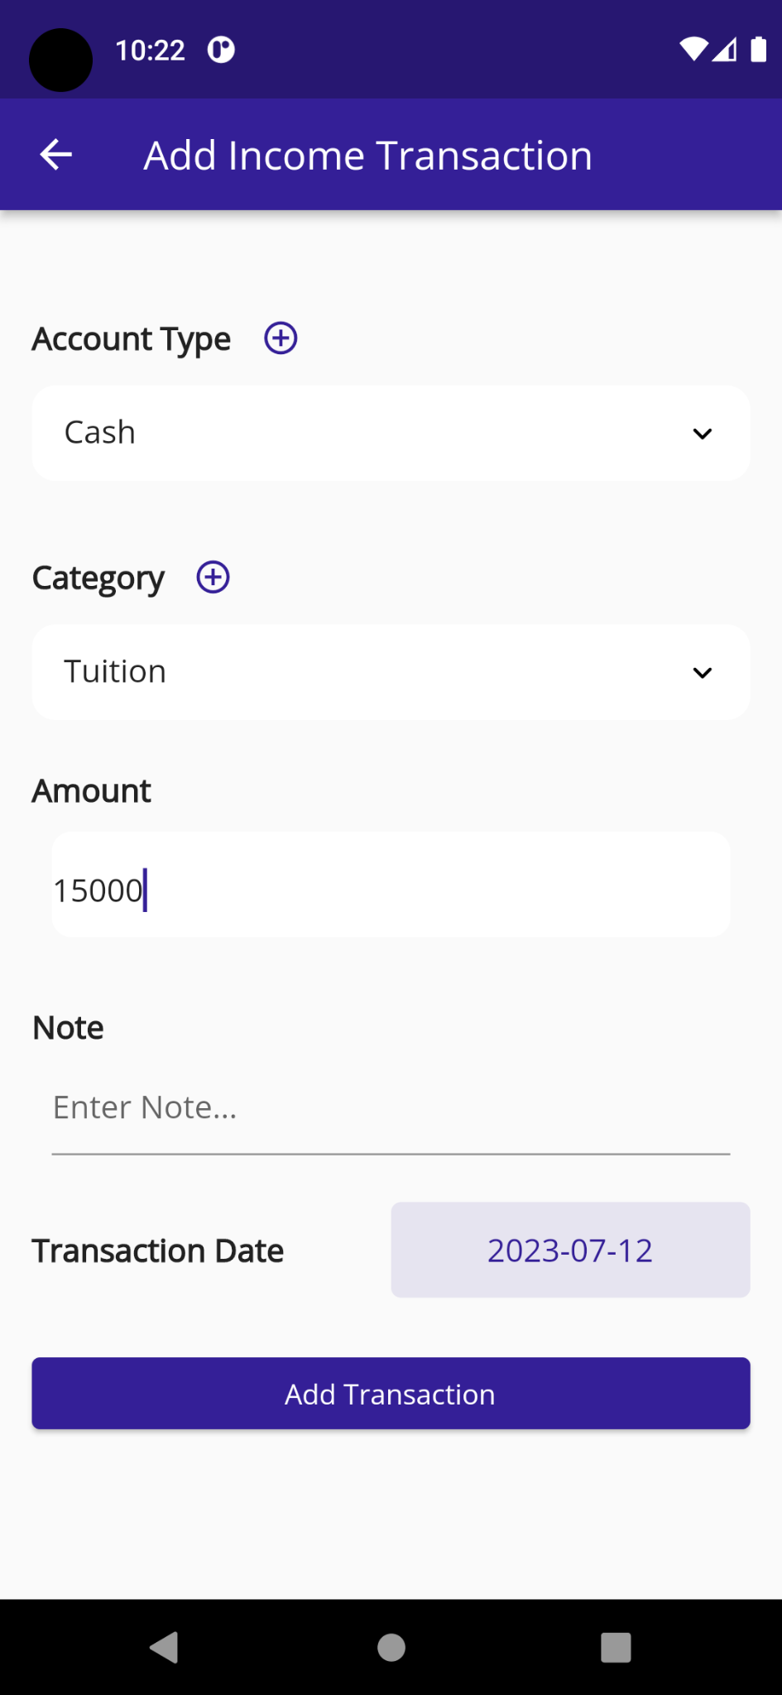

**Add Transaction Screen**: after clicking the add transaction button from the homepage screen, user will see these screen page. After input and select all the info, user must click the Add Transaction button to add the input transaction. Here account type, category and amount are mandatory field. User can also add new account and category by clicking the respective plus icon button.

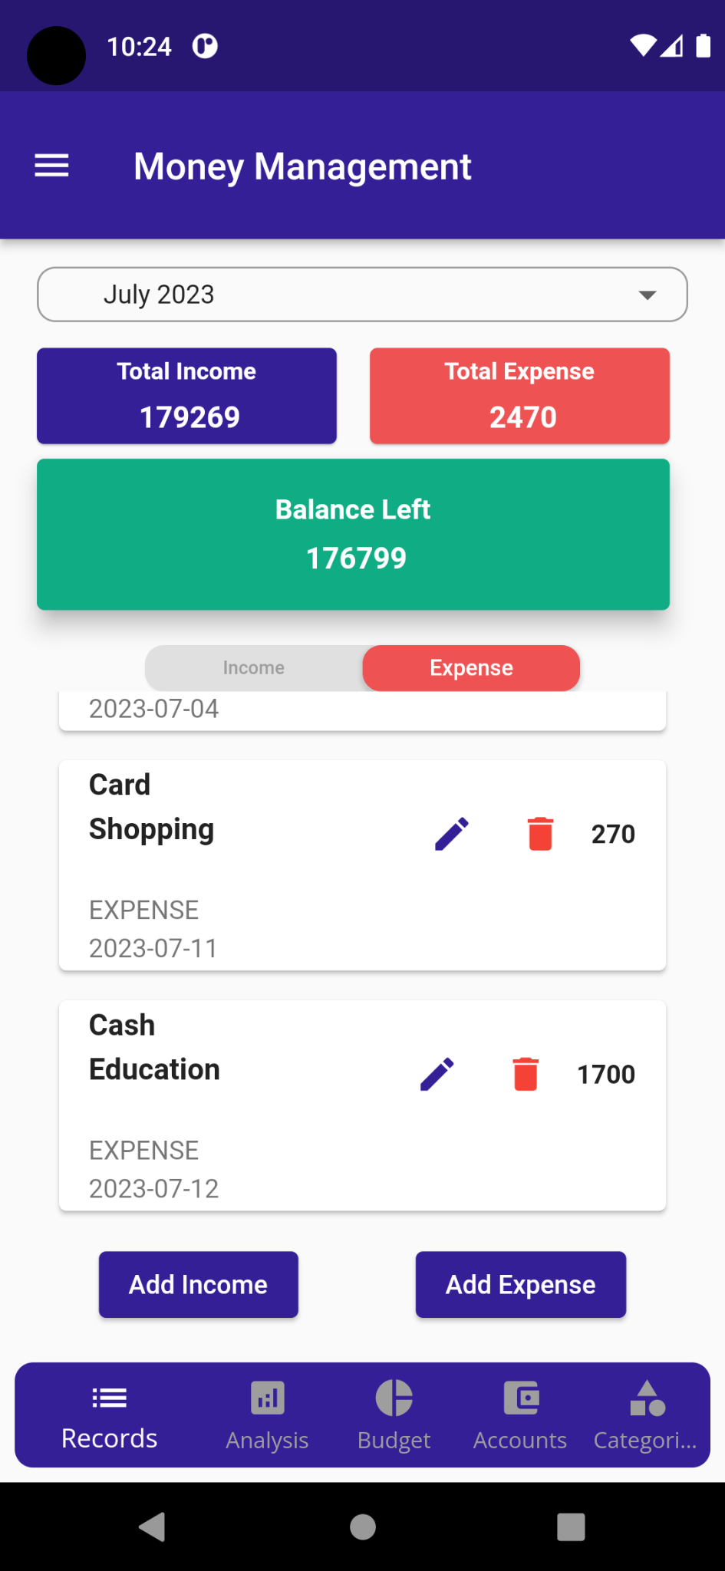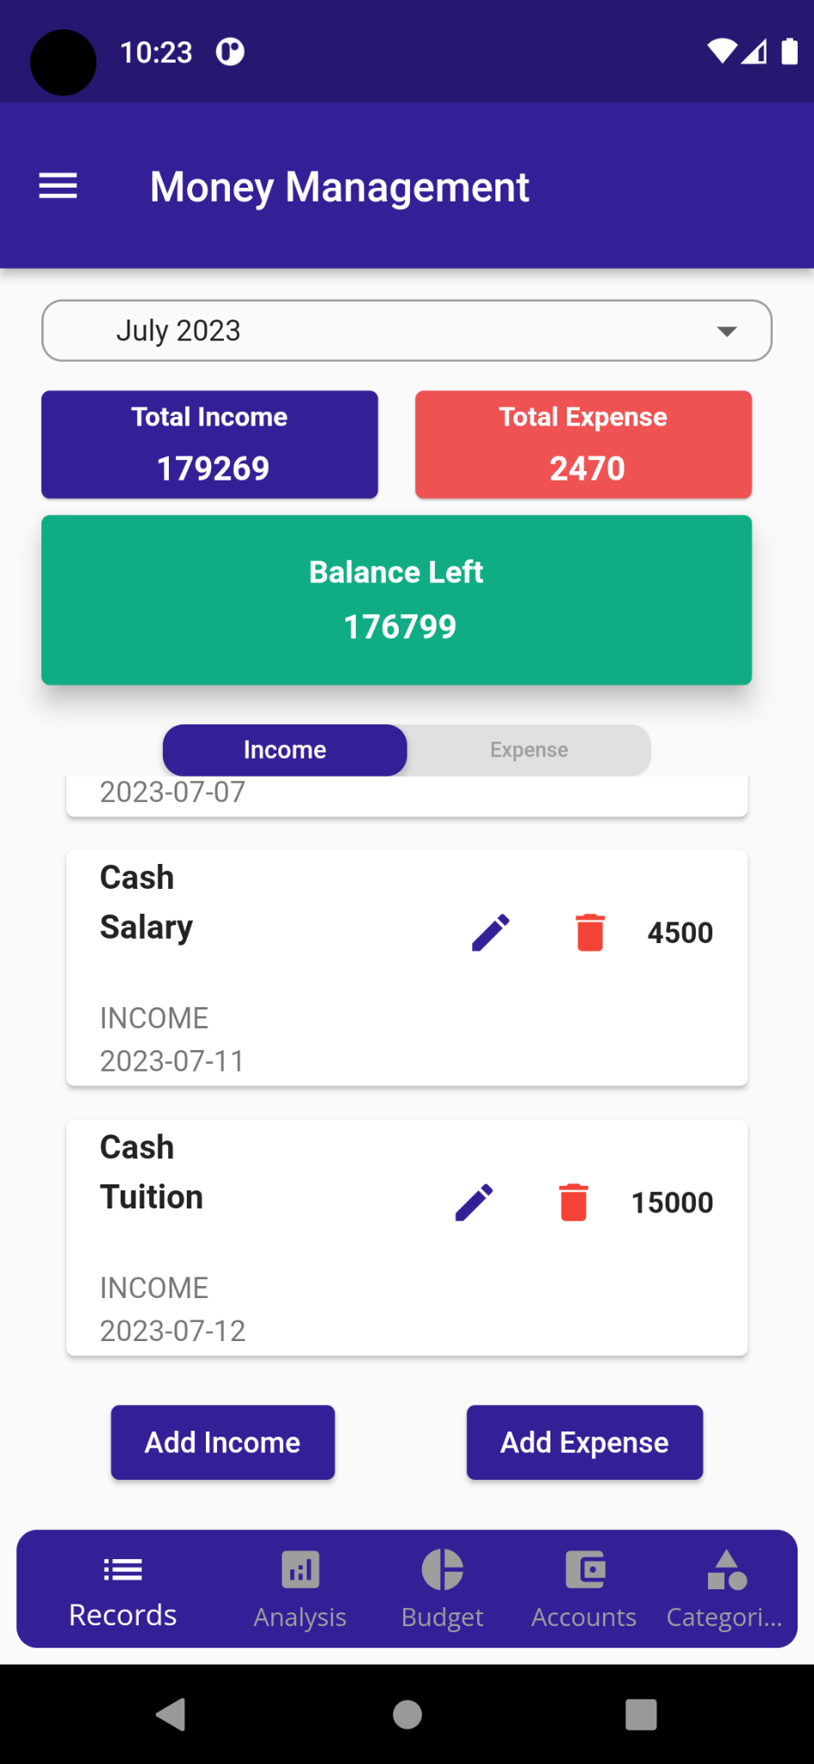

**Home Page/ Record Screen:** after successfully adding the new transaction user can see those in the transaction list from the Record Screen.

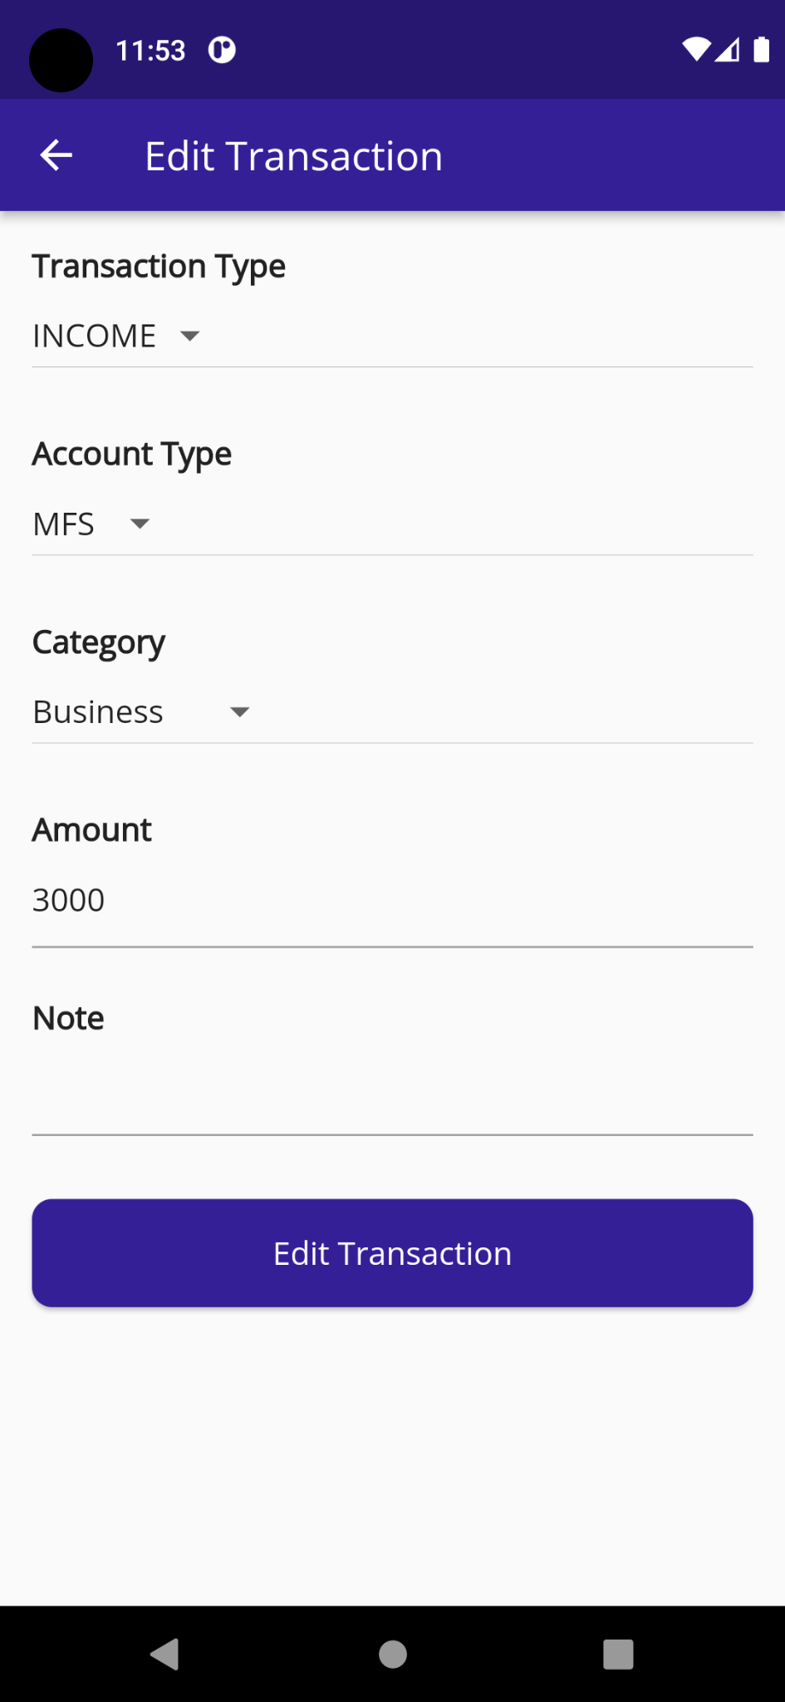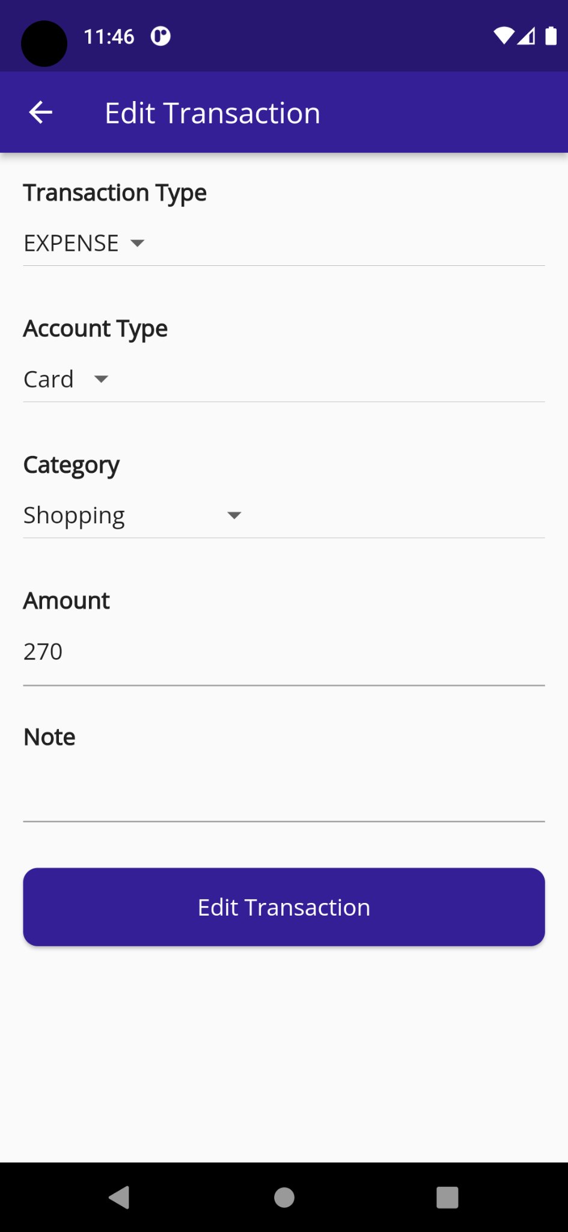

**Edit Transaction Screen**: after clicking the edit icon button in a specific transaction item from the homepage screen, user will see this edit transaction screen page. After change the desired info, user must click the Edit Transaction button to change the transaction info. Here account type, category and amount are mandatory field.

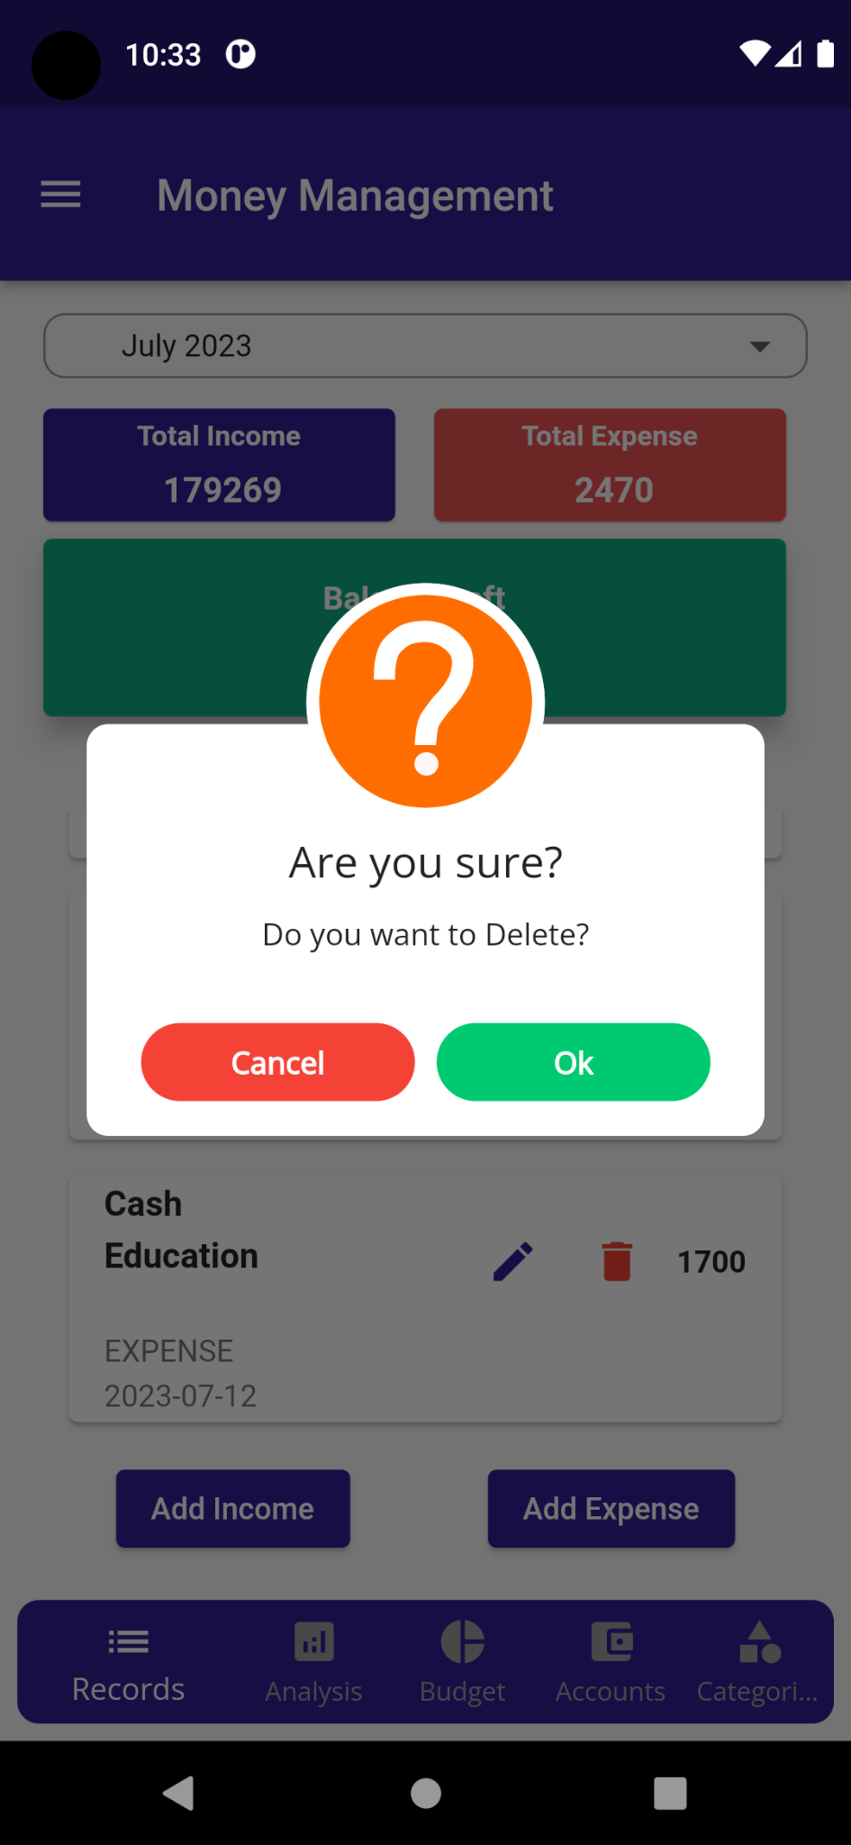

**Delete Screen:** If user want to delete any item from any item list then user simply click on delete icon to delete the specific item. After clicking the delete icon , user will see a popup window to confirm it like this screenshot page. Then user click on the confirm button to confirm it, without it user can cancel the operation by clicking the cancel button.

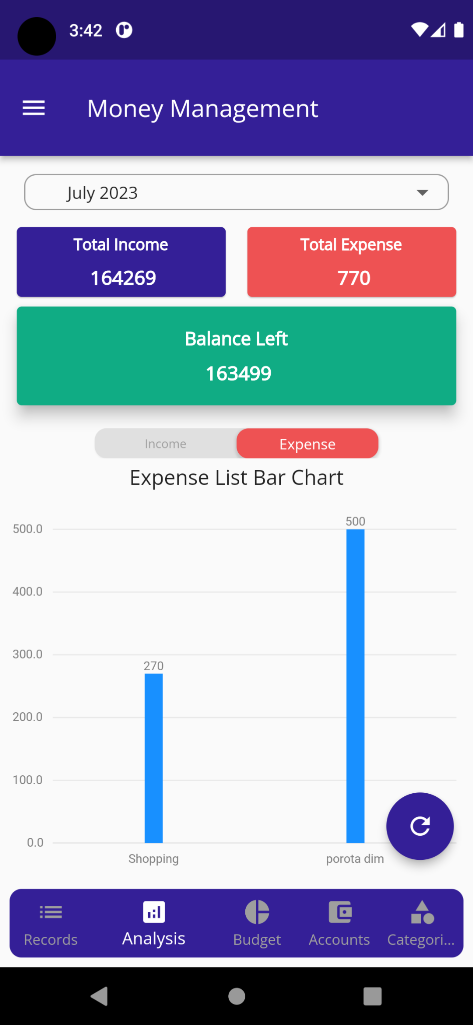**Analysis Screen:** When user will click on the Analysis tab from the bottom navigation bar, user will see this page. Here user can see the income and expense list graphically. User also switch the income and expense tab to change the income and expense graph. User can select or set the specific date range to see the income and expense list within that range. 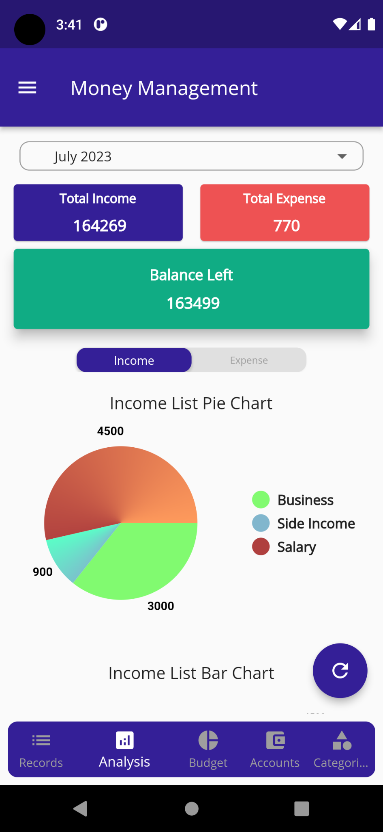

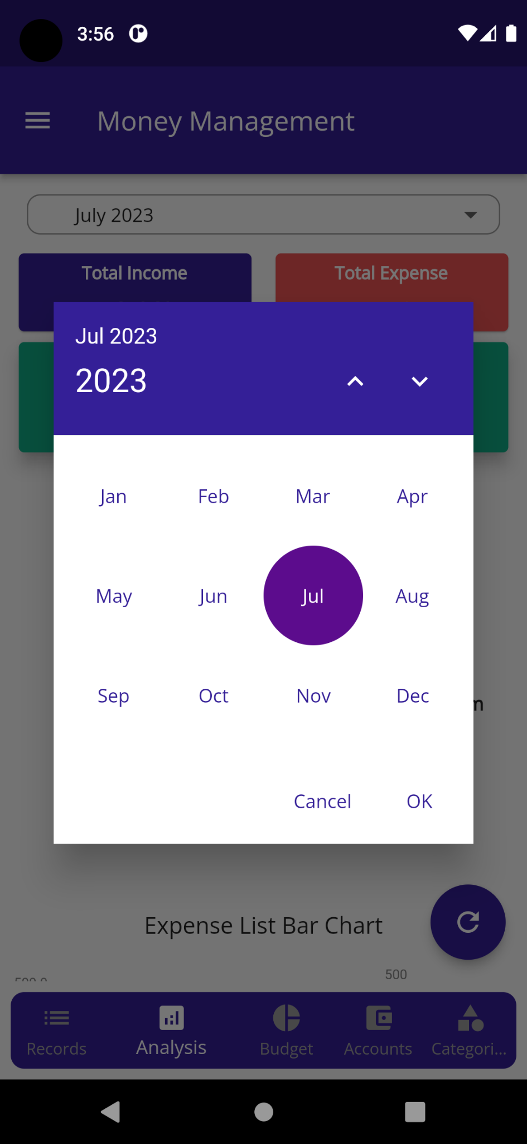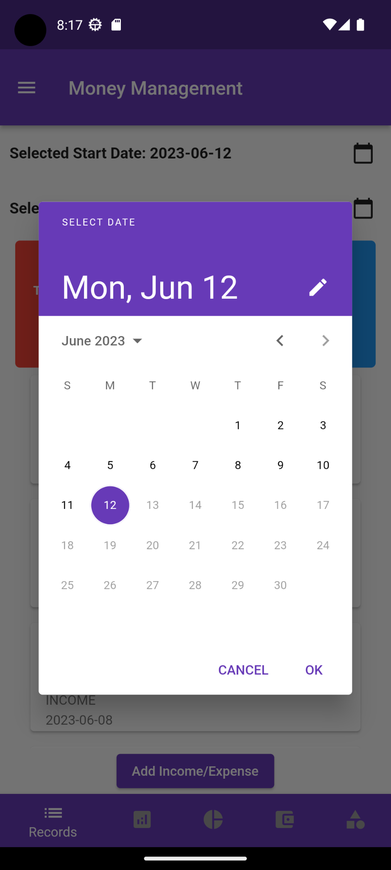

**Date Selection Screen:** from the date selection dropdown menu when user select the **Custom** button, then user will see the first date selection page to select the date and when user select the month button then user will see the second month year selection page to set the month.

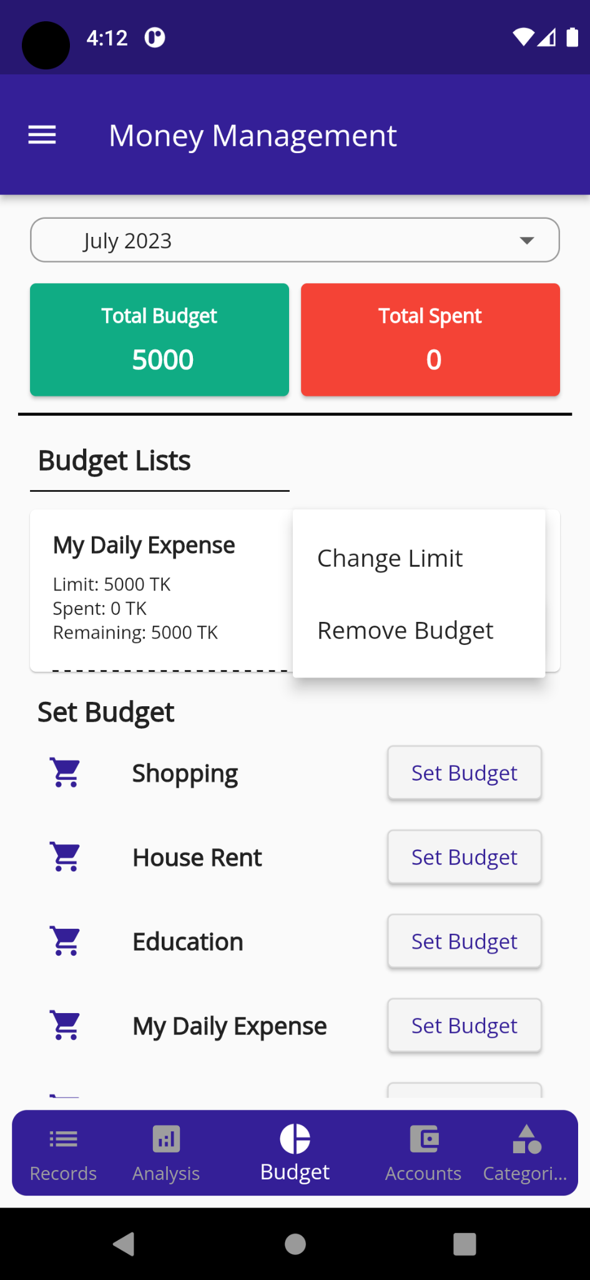

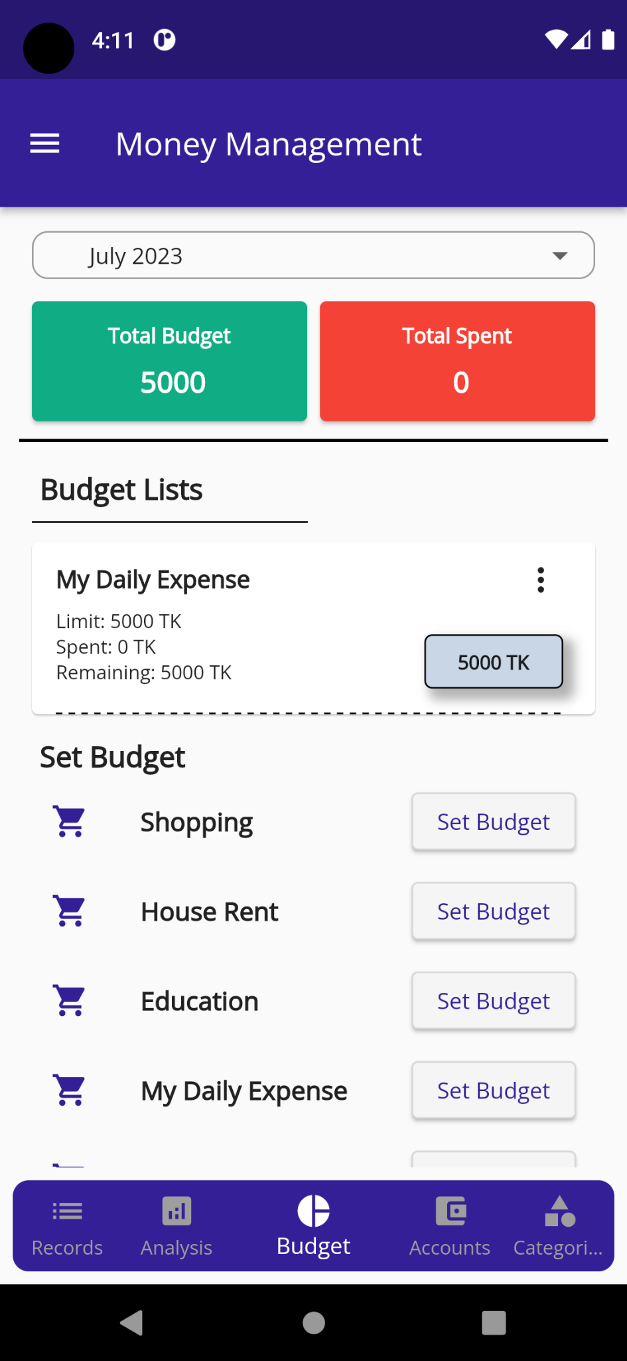**Budget tab:** user will see this page after clicking the **Budget** tab from the bottom navigation bar. Here user can see previous budget list and expense categories list to set the budget and total budget and total spent amount. Also, when user click on the three dot button, user will see a popup dialogue box with two additional button like change limit and remove budget. By clicking the change limit button user can edit the budget limit for that item and also user can remove the budget from the budget list by clicking the remove budget button.

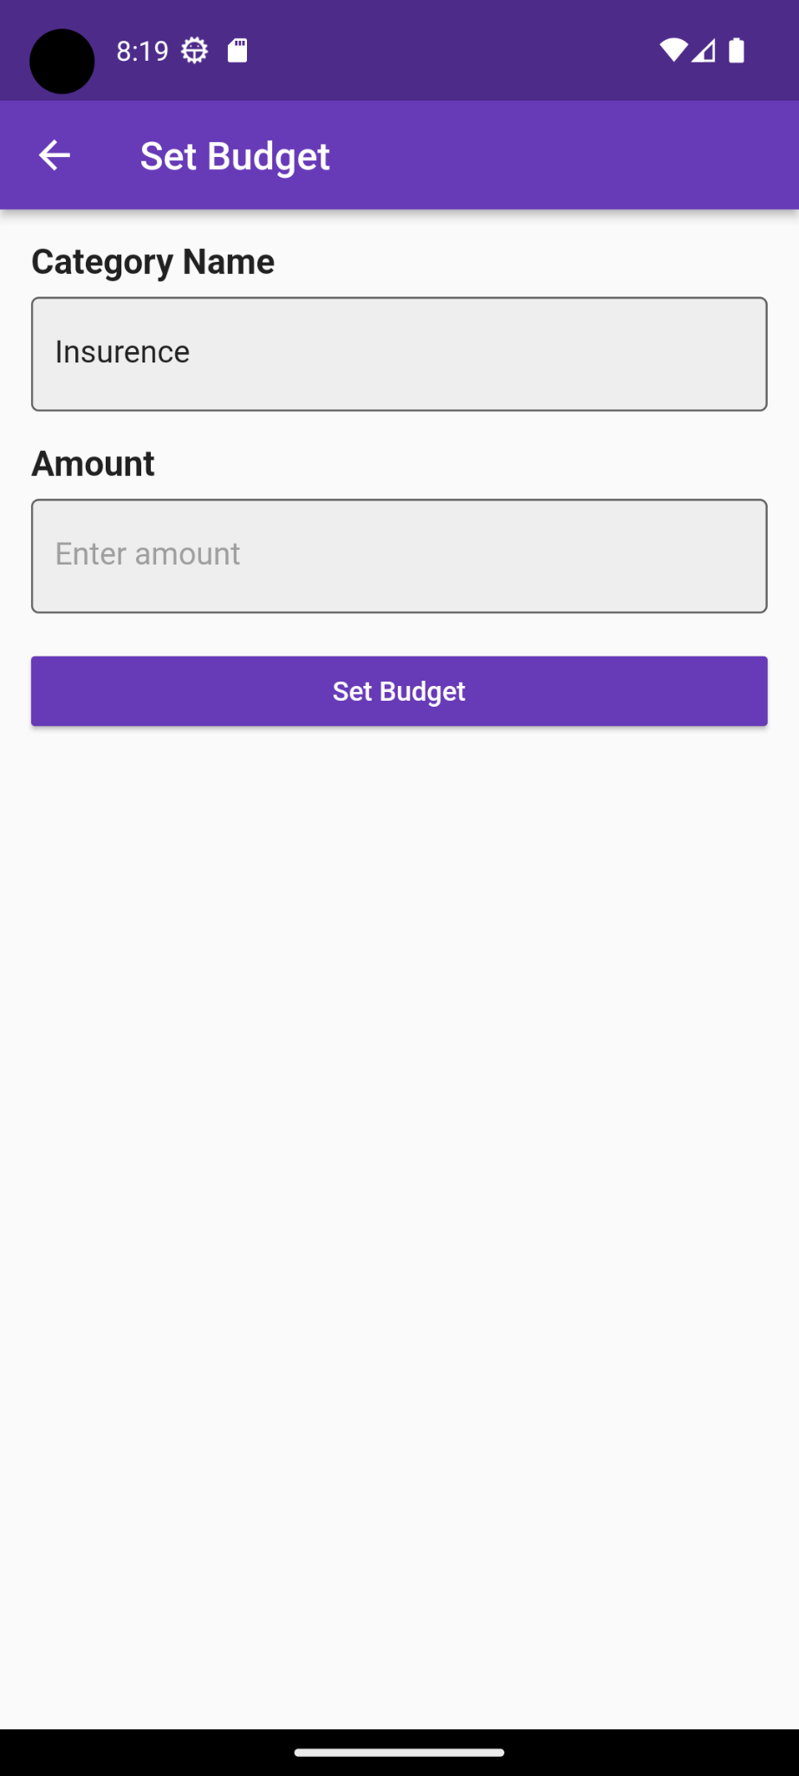

**Set Budget Screen:** After clicking the set budget button from the budget screen, user will see this page. Here, user have to select the Category type and input the budget amount to set the budget. Then, user will click the set budget button to add it on the budget list.

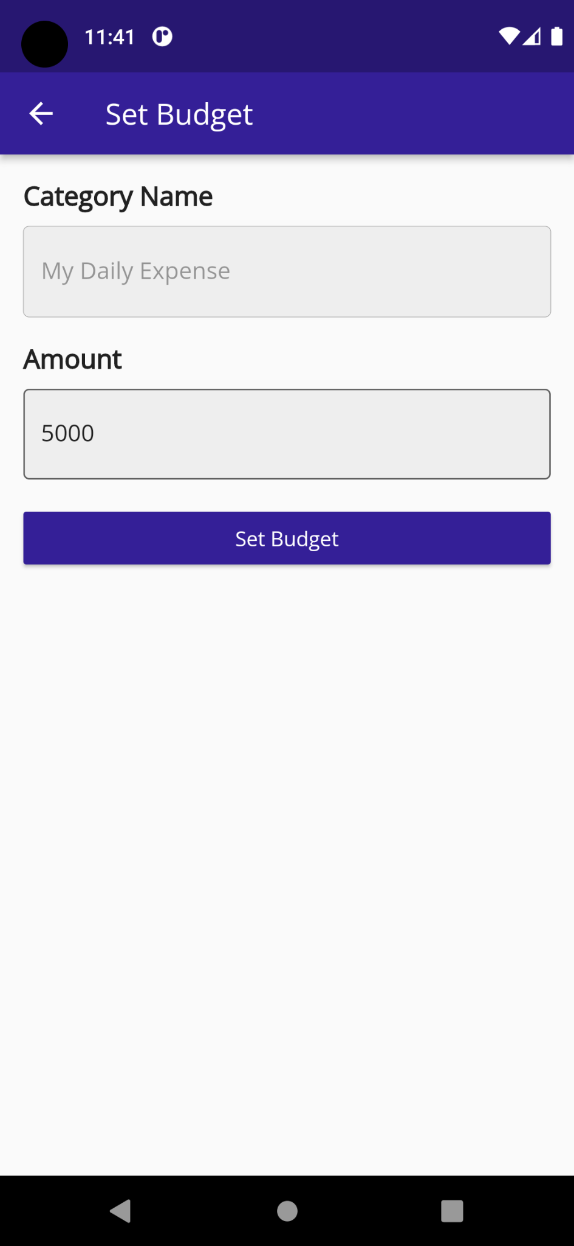

**Change Budget Limit Screen:** After clicking the change Limit button from the budget screen, user will see this page. Here, user just input the new budget amount to set the budget. Then, user will click the set budget button to change it on the budget list.

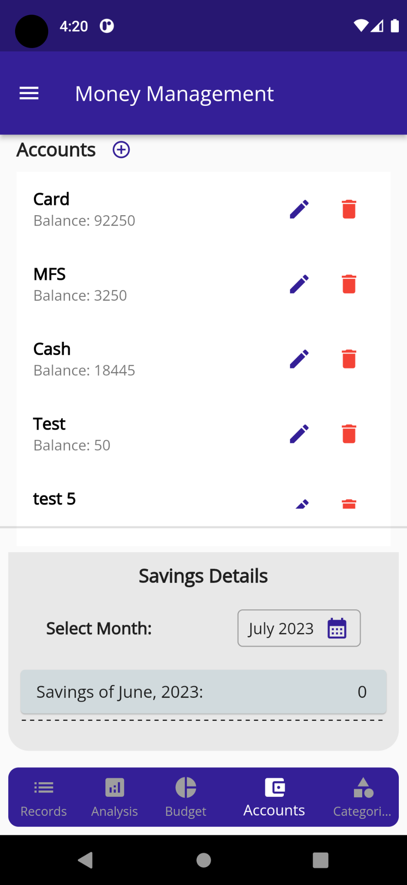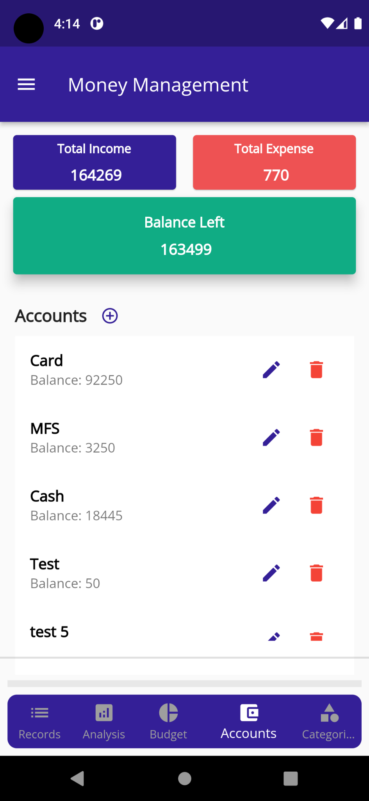

**Account Screen:** When user will click on the Account tab from the bottom navigation bar, user will see this page. Here user can see previously added accounts list, edit-delete account button and add account button on the bottom right corner of the screen.

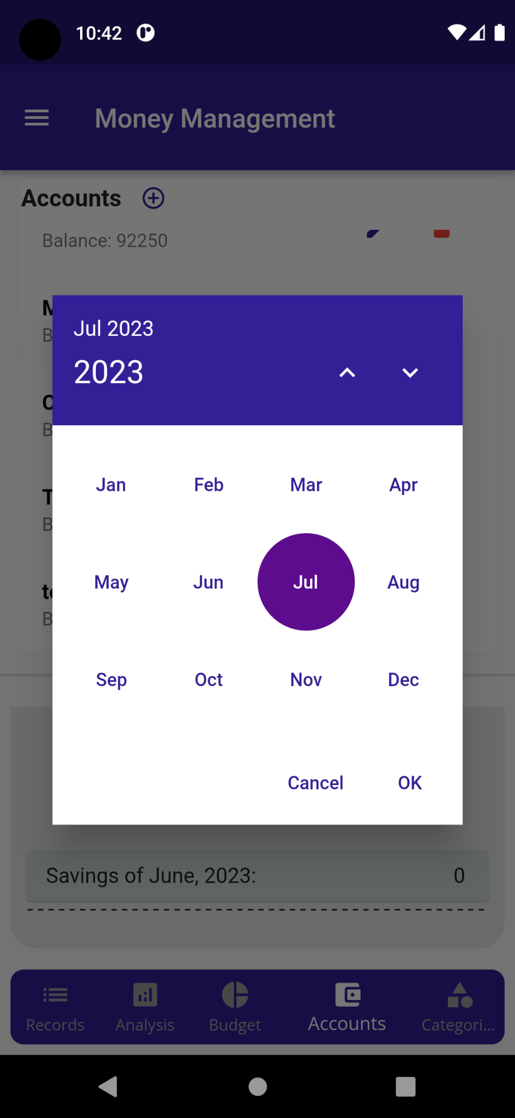

**Savings Date Selection Screen:** when user click on the savings date range button from the Account screen, then user will see this month year popup window to set the month.

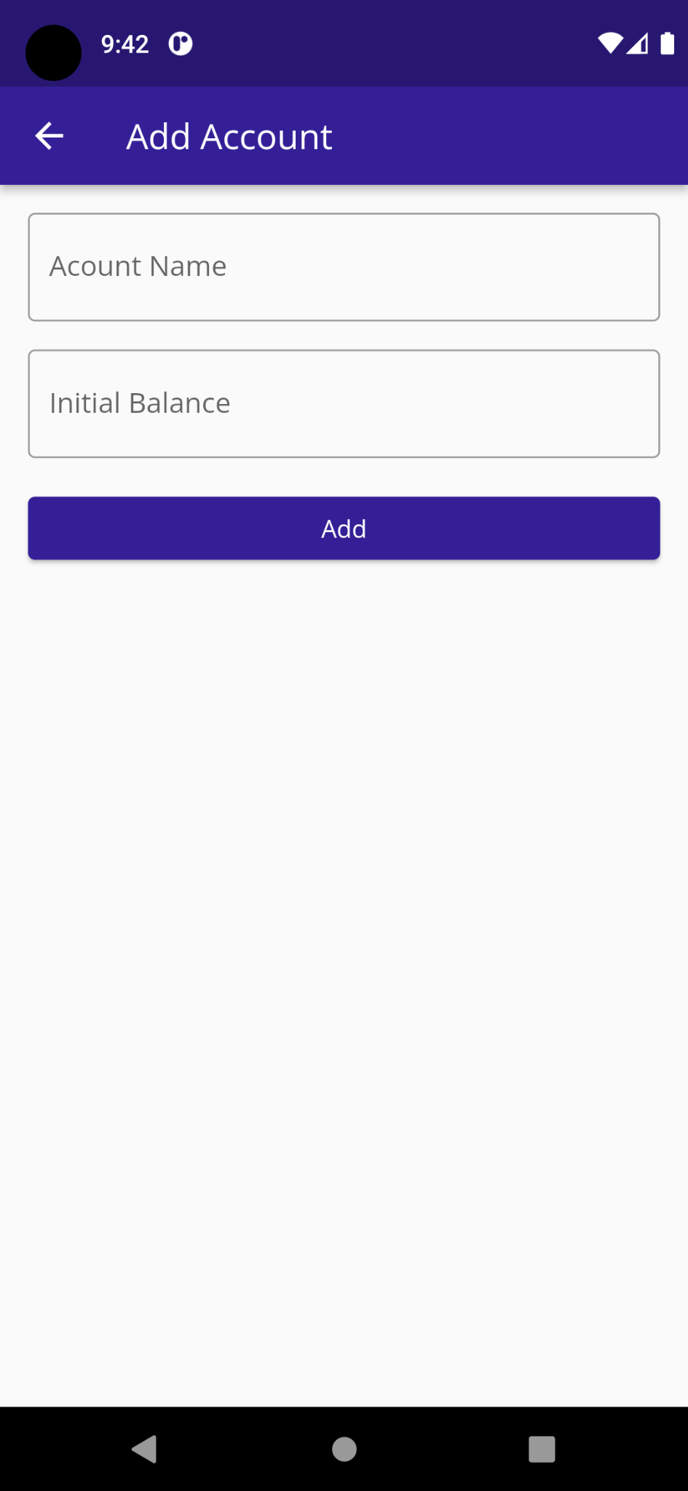

**Add Account Screen:** after clicking the plus icon button from the account page, user will see a popup window to add new account. Where user must have to input the account name and initial balance , and then click the ok button to add it.

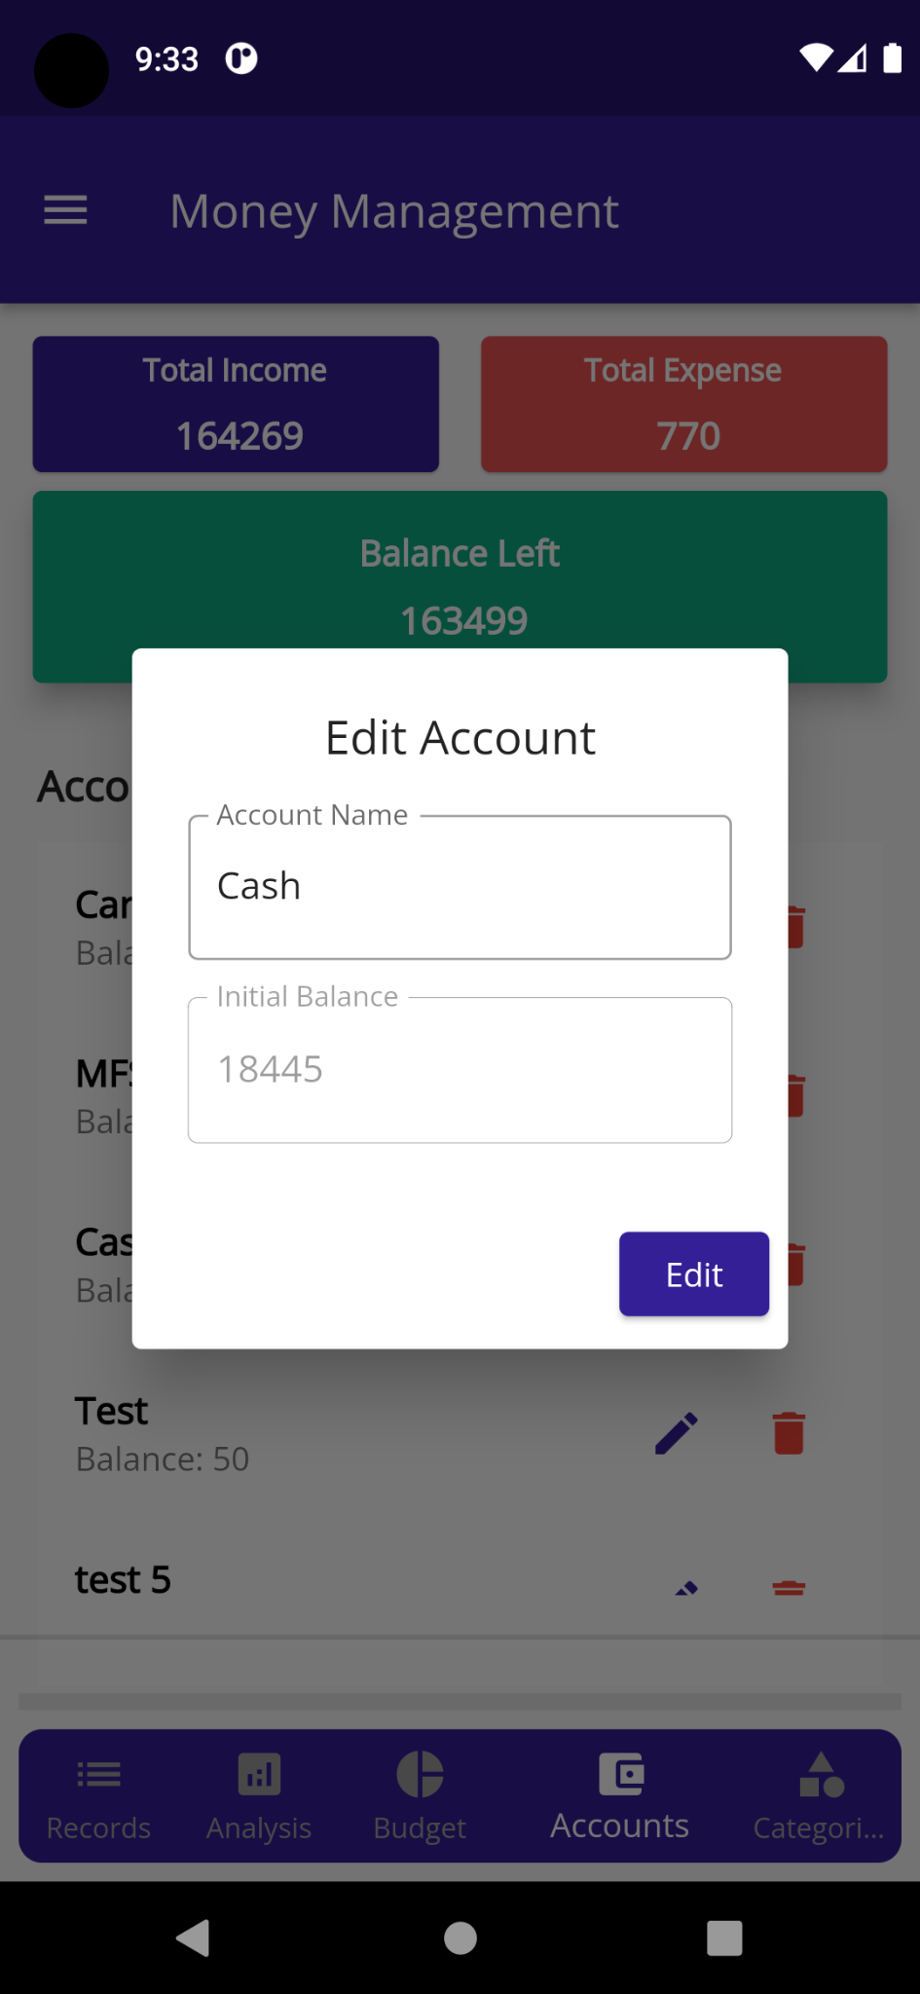

**Edit Account Screen:** after clicking the specific account edit button from the account page, user will see a popup window to edit that account info.

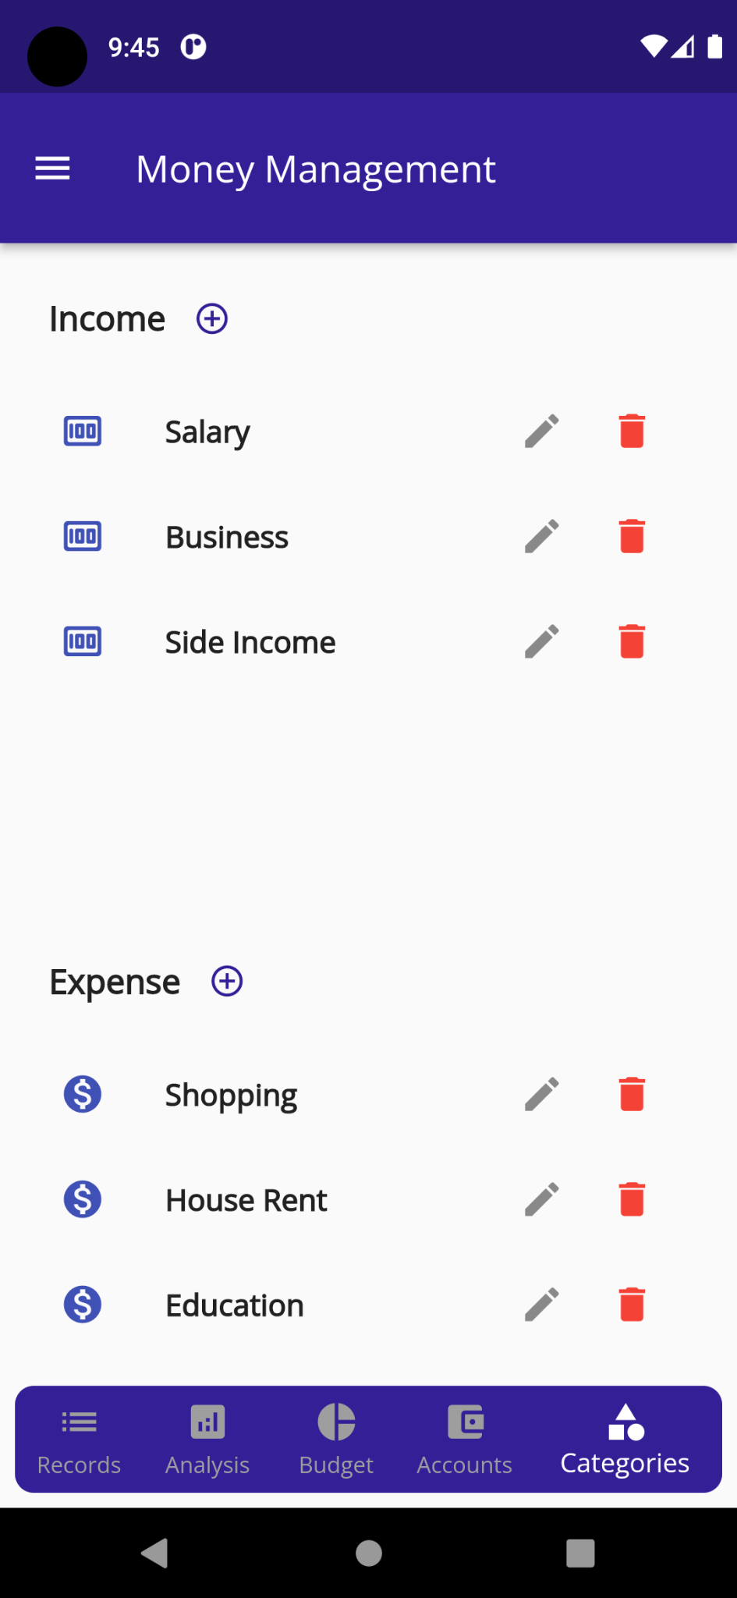

**Category Screen:** When user will click on the Category tab from the bottom navigation bar, user will see this page. Here user can see previously added category item list, edit-delete category button. User can also see add category icon button on the right side of the respective category type name in the screen.

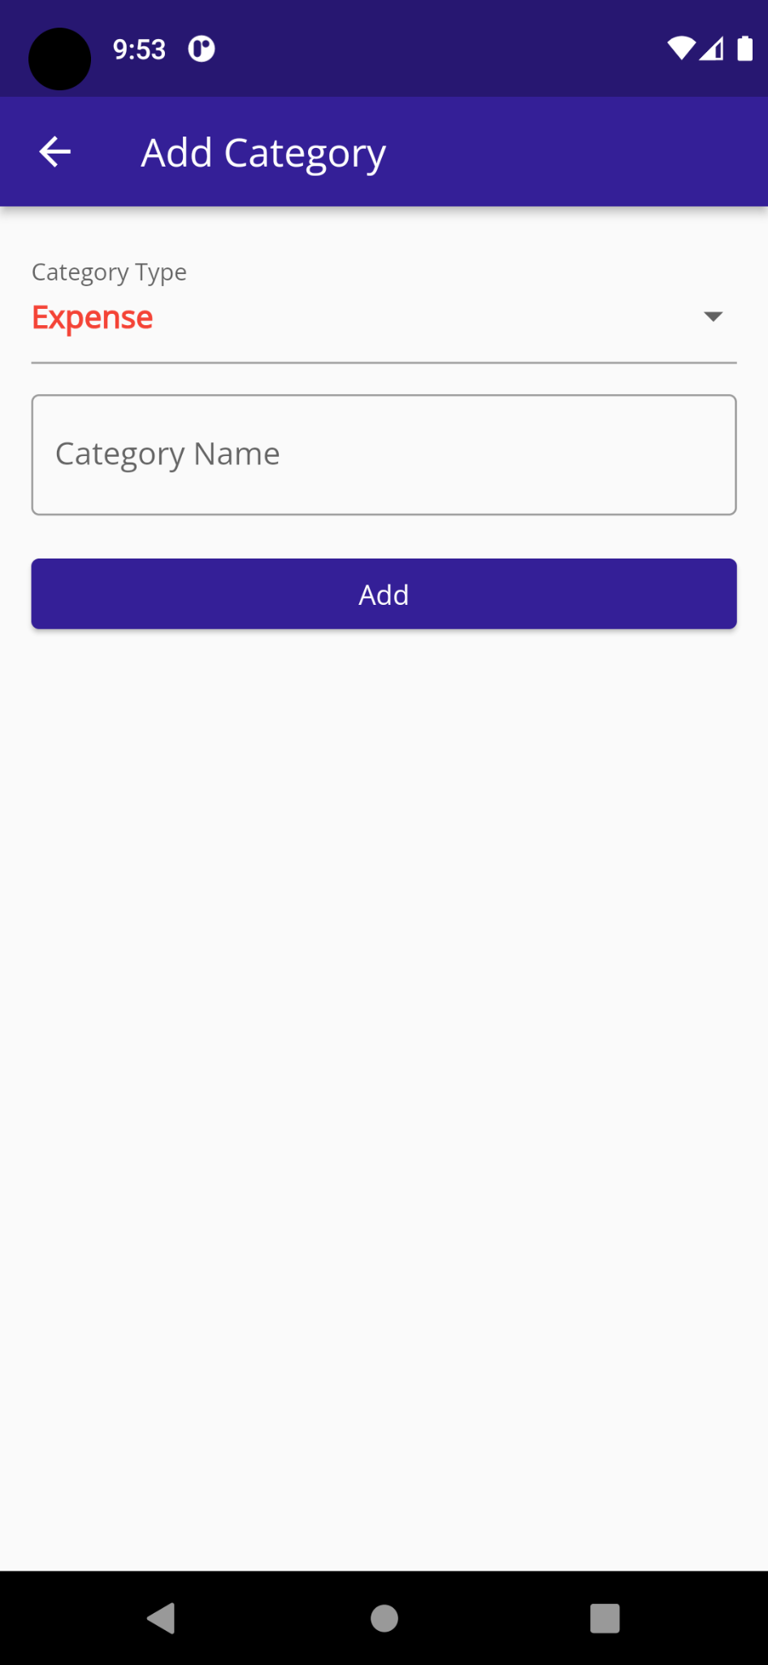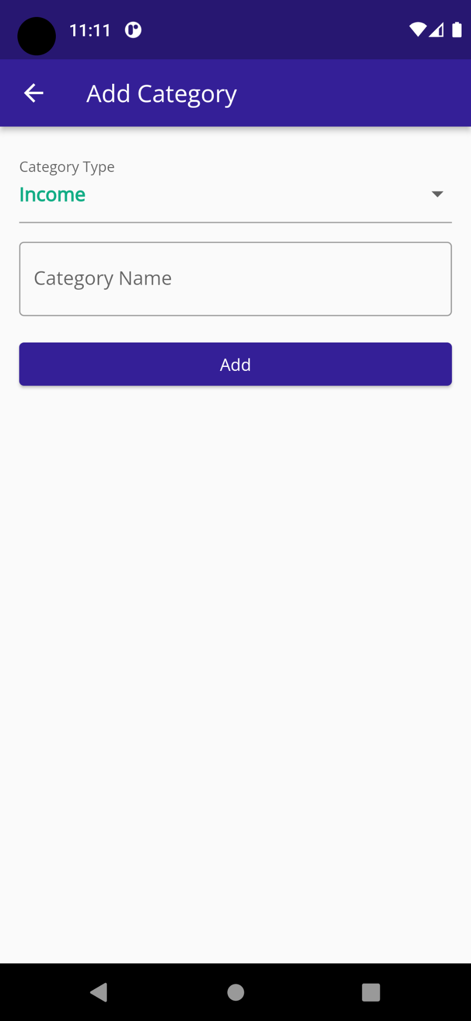

**Add Category Screen:** When user click on the add category icon button from the category screen, then user will see the respective category screen like these. Here, user will input the category name and then click the add button to add the category on the category list.

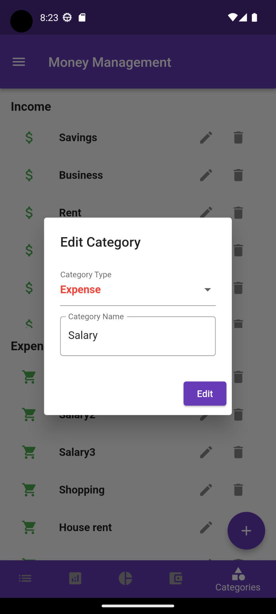

**Edit Category Screen:** When user click on the edit category icon button in a specific category from the category screen, then user will see this screen. Here, user can edit the category type and the category name and then click the edit button to add the category on the category list.

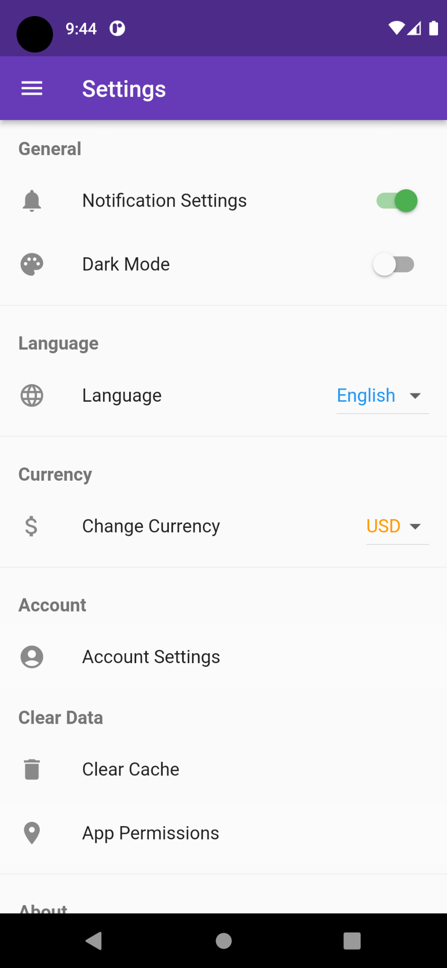

**Settings Screen:** when user click on the settings button from the side navigation panel, then user will see this page. Here user will find different app features like notification settings, dark mood, language, change currency, account settings etc. From this screen, user can also clear the app data, change different app permission, know about the application and give feedback about the app by clicking the respective button.

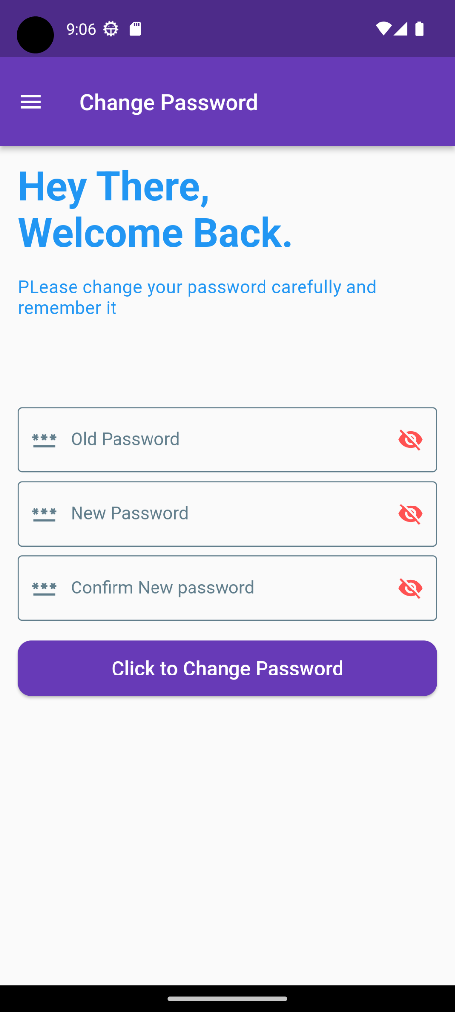

**Change Password Screen:** when user click on the settings button from the side navigation panel drop down window, then user will see this page. Here user have to input the old password first and then input the new password twice for verification. After that user have to click on the change password button to change the password permanently.

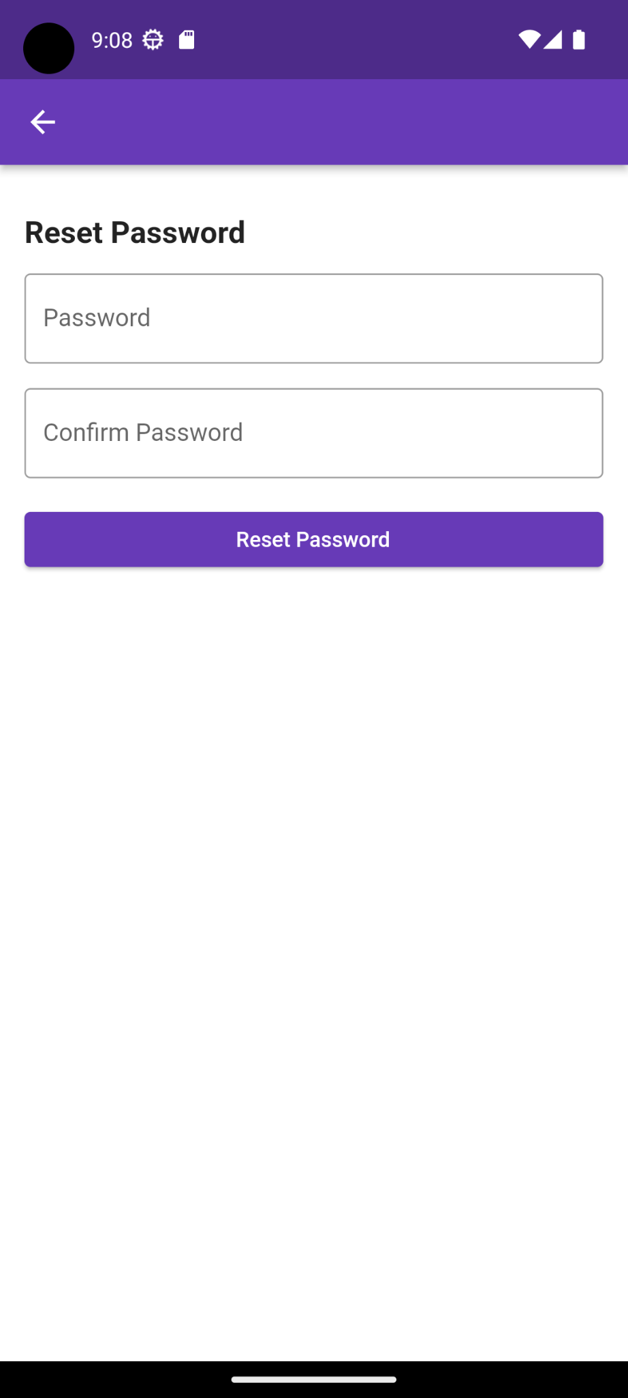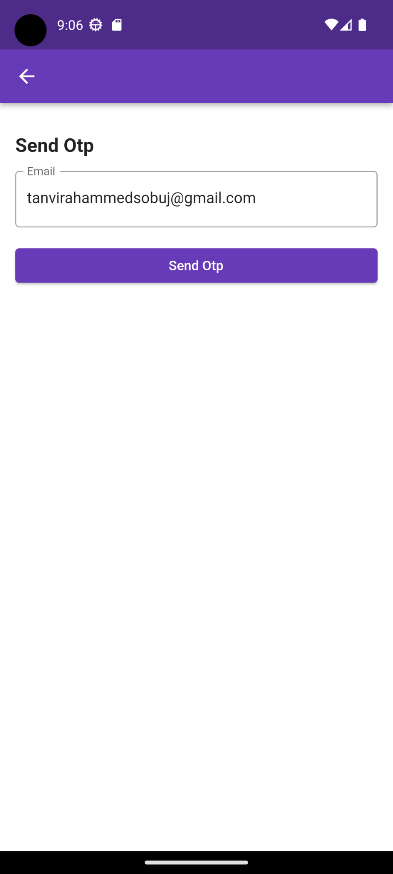

Image-1 image-2 image-3

**Forget Password Screen:** if user forget his or her credential then, to recover it user can click on the forget password button from the sign in screen, then user will see the image-1 page. Here user first input the registered email and click on send otp button. Then user will see the image-2 page and also get a otp on the entered email box. After that user have to input that otp on the image-2 opt form and click on the submit button. Finally if the otp match then user will see the image-3 page. Here user will input the new password two times to confirm it and click the reset password button to reset the new password permanently.

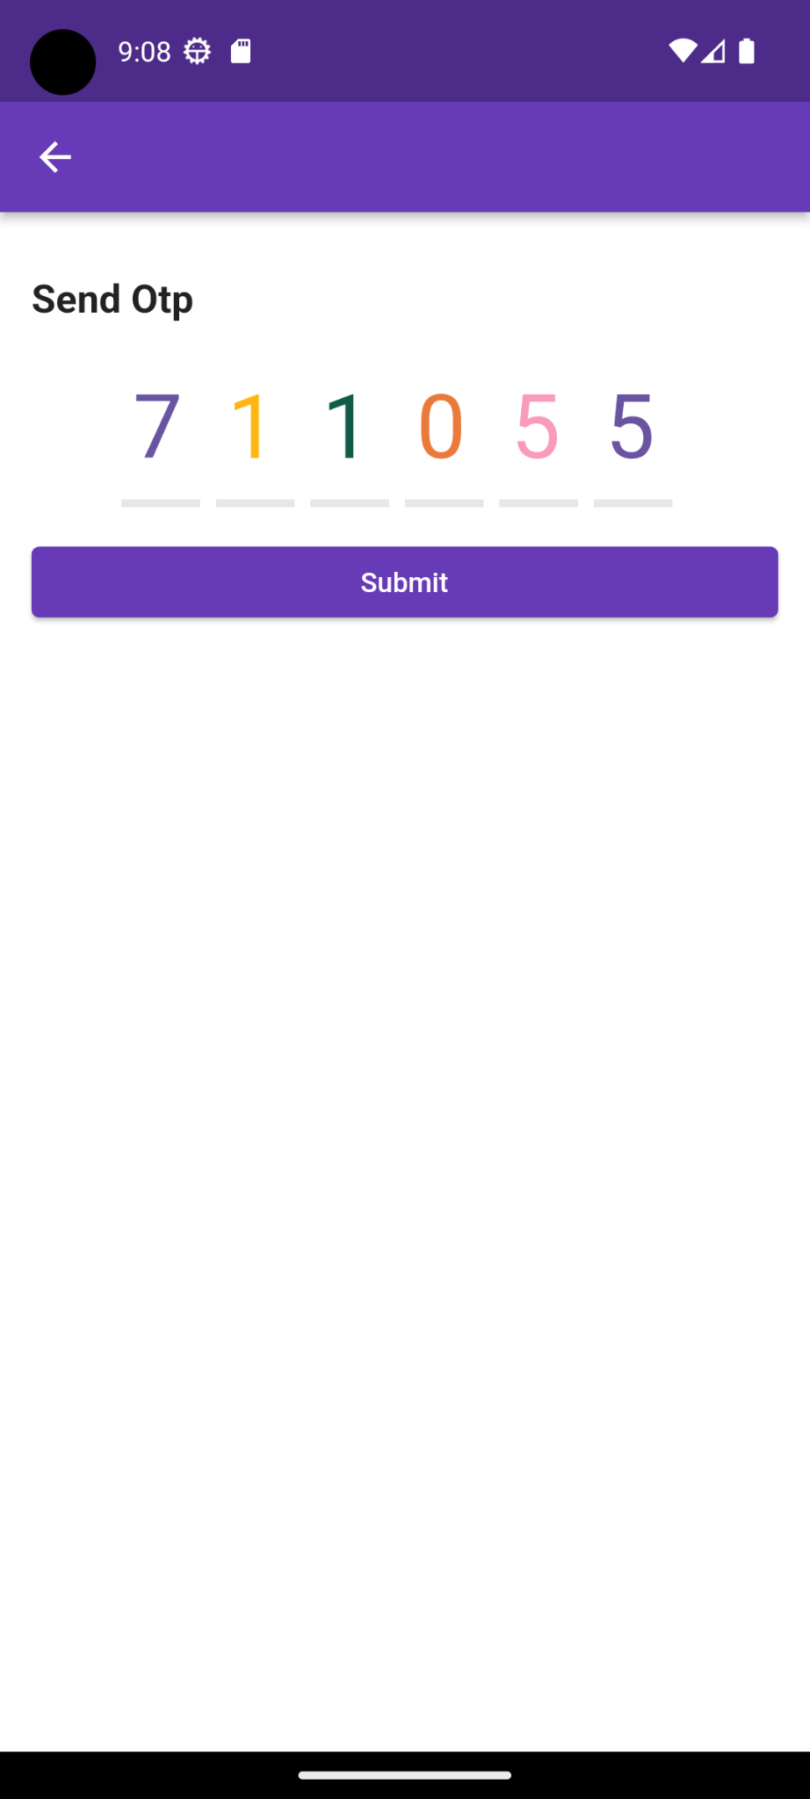

Thank You